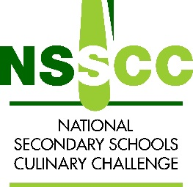

NSSCC Grand Finale Recipe and Method Card 2023

Course:__________ Portion Size: 4 Team Name: _______________________
Weight | Ingredients

Weight | Ingredients

Method:

