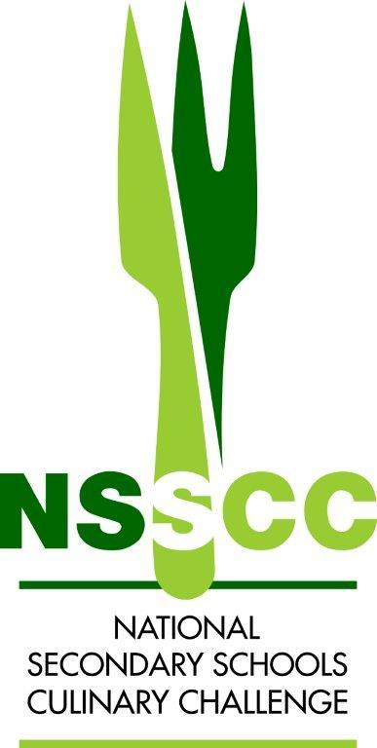

NSSCC Regional Online Competition
Recipe Template 2026


School:
Team Name:
Competitors: | 1. | 2.

Course: Entrée Portions: 2

Weight | Ingredient |  | Weight | Ingredient
Method:

Step/Timing  e.g  1. 5-10 mins | Dice onions and saute in butter with garlic until translucent
School Team Name:

Step/Timing

